

**US Army Corps of Engineers**

**Afghanistan Engineer District**

AED Design Requirements:

Culverts & Causeways

Various Locations, Afghanistan

JULY 2009, Version 1.3

**TABLE OF CONTENTS**

AED DESIGN REQUIREMENTS FOR

CULVERT /CASUEWAY DESIGN VARIOUS LOCATIONS, AFGHANISTAN

**Section Page**

**1. General 2**

**2. Culverts 2**

**2.1. Criteria 2**

**2.2. End Treatments 3**

**2.3. Aprons and Cutoff Walls 3**

**2.4. Types of Flow Control That Determine Culvert Capacity 3**

**2.5. Culvert Design Nomographs 4**

**3. Causeways 5**

**3. 1 Criteria 5**

**3. 2 Debris Control 6**

**4. Design Submittal Documentation 6**

**5. References 7**

**Appendix A - Culvert Design Procedure**

**Appendix B - Culvert Design Example & Design Form Appendix C - Culvert Debris Protection Devices Appendix D - Causeway Debris Protection Devices**

**1. General**

The purpose of this document is to provide requirements to contractors for any project requiring hydraulic design of drainage structures crossing roadways. Culverts, gabion crossings, at-grade concrete wadi crossings or other related structures shall be constructed as required over rivers, dry wadis, canals and other manmade channels that contain water and deep drainages that fill with water during the rainy season. Road sections that cross wide drainages, flood areas or wadis shall be designed and constructed with additional erosion control measures to allow the road to be passable and minimize damage during frequent rain conditions. High erosion areas, such as shallow drainage crossings and wadis, shall be armored with a hard surfaced crossing such as rip rap and provided with debris catchment devices such as STRAFLIN debris barrier or steel debris cage. Culverts smaller than 1m by 1m shall not be constructed; using instead low water crossings (also known as causeways). Causeways shall be built according to Ministry of Rural Rehabilitation and Development (MRRD) standards shown in Reference 1. All existing culverts smaller than 1m by 1m than require replacement shall be replaced with low water crossings; exceptions will be considered by the contracting officer only on a case by case basis.

**2. Culverts**

**2.1 Criteria**. Culverts will be used to convey runoff under roads, runways, perimeter walls, or other similar site features in order to prevent the ponding of runoff that may cause a hazardous condition and to prevent damage to site features. The Contractor shall include the following criteria while designing a culvert.

1) All culverts shall be hydraulically designed to pass the peak design flow from the selected design storm. The design storm (return period) selected shall be consistent with the class of road, highway or airfield type.

2) Culvert material selection shall include consideration of service life that includes abrasion and corrosion. Unreinforced concrete culverts are not permitted. Slab culverts constructed to MRRD standards are accepted.

3) Culverts shall be located and designed to present minimum hazard to traffic and people.

4) Culvert length and slope shall be chosen to approximate the existing topography. Culvert invert shall be aligned with the existing channel bottom and the skew angle of the channel to the maximum extent possible.

5) Culverts shall have a minimum of 0.60 meters of cover within the travel way of roads.

6) Allowable headwater is the depth of water that will be allowed to pond at the upstream end of the culvert during the design storm which will be a minimum of 0.45 meters below the edge of the shoulder of the road being crossed. The headwater shall be determined as part of the hydraulic analysis.

7) Maximum velocity at the culvert exit shall be consistent with the velocity in the natural channel or shall be mitigated with channel stabilization or energy dissipation using riprap, gabions or boulder flow stilling designs.

8) Design velocity at the peak design discharge rate determined from the hydrological analysis (see Reference 2) in the culvert shall be greater than 1 meter/second for sediment transport conveyance capacity.

9) Contractors are encouraged to adapt the geometry (i.e. shape and slope) of the standard MRRD culvert and causeway design drawings to site conditions where applicable. For example, reinforced box culvert cross slopes should be adjusted to existing channel grade

requires future maintenance to obtain design capacity.

**2.2. End Treatments**

Culvert end treatments are to be provided in specified in the contract technical requirements. Circumstance that require the use of end treatments include construction of the culvert at a severe skew angle to the flow path of the channel which requires a redirection of the flow into the culvert, and where the culvert is covered by a high embankment which requires that erosion around inlet and outlets be minimized used an end treatment. The culvert end treatment type shall be selected based on the diameter of the culvert and the potential hazard to errant vehicles. All culverts larger 1200 mm in diameter and larger should have headwalls and wing walls or shall be mitered to the slope and protected by grouted masonry, and rip rap outlet protection aprons. Where headwalls, wing walls or mitered ends are used, the culvert ends should be extended a sufficient distance from the travel lanes so that there is no hazard to errant vehicles or a traffic barrier (guard rail) should be installed adjacent to the headwall or wing wall. Examples of end treatments are provided in Figure 1. Other examples are found in the MRRD standard drawings (Reference 1).

Figure 1. End Treatment Examples

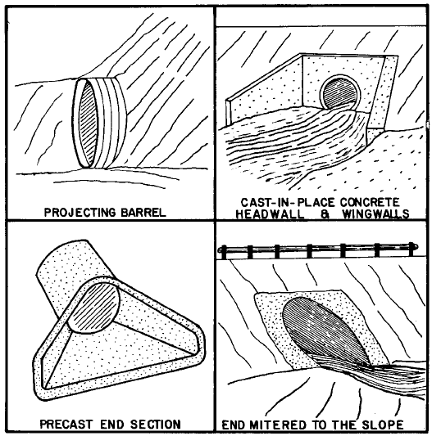

**2.3. Stone Aprons and Cutoff Walls**

Approach aprons and or cutoff walls should be used to reduce scour from high headwater depths or from approach velocity in the channel. Approach aprons should be concrete or large diameter rip-rap and shall extend at least one pipe diameter upstream of the culvert entrance. MRRD culvert standard drawings provide details of aprons and cutoff wall design. See MRRD standard reinforced box culvert drawings DCV-05 and 06. Approach aprons should not protrude above the normal streambed elevation. Outlet protection shall be provided at the downstream end of all culverts where the culvert discharge velocity is greater than the natural channel velocity.

**2.4. Types of Flow Control That Determine Culvert Capacity**

The hydraulic capacity of the culvert depends upon the type of hydraulic control at the design flow rate for the culvert. Type of control refers to the inlet and outlet water surface elevations of the

For supercritical flow, the control section of the culvert is the upstream end of the barrel (inlet end). Conversely, a culvert flowing under outlet control will have a relatively deep, low velocity flow categorized as “subcritical”. The “tail water”, that is the natural channel flow depth at the end (or tail) of the culvert limits the flow capacity of the culvert because of natural channel capacity. Typically the flow will be subcritical under this condition. For subcritical flow, the control section of the culvert is either the downstream end of the culvert barrel or the outlet channel section. The tail water depth is either the critical flow depth at the culvert outlet or the downstream channel flow depth, whichever is higher. For all culverts, the type of flow is dependent on all of the factors listed Table 1.

All of the factors influencing the performance of the culvert in inlet control also influence culverts in outlet control. In addition, the barrel characteristics (roughness, area, shape, length and slope) and the tail water elevation affect culvert performance in outlet control. Roughness is a function of the material used to fabricate the barrel. Typical materials include concrete and corrugated metal. The barrel area is the cross-sectional area of the barrel and the barrel shape is the shape of the barrel (circular, square, rectangular, etc.). The barrel length is the total culvert length from the entrance to the exit of the culvert. Because the slope influences the actual length of the barrel, an approximation of the barrel length is usually necessary to begin the design process. The barrel slope is the actual slope of the barrel which is the difference of the inlet and outfall ends of the culvert divided by the length of the culvert.

Table 1. Factors Influencing Culvert Performance

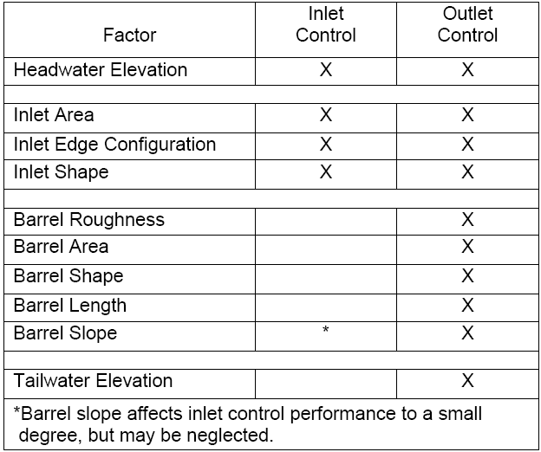

**2.5. Culvert Design Nomographs**

The design of culverts is normally achieved using design forms and nomographs for inlet control and outlet control and critical depth charts. The use of the Manning’s equation alone is insufficient to establish the principal design parameter the headwater on the culvert at the road embankment. A nomograph is a chart usually containing three parallel scales graduated for different variables so that when a straight line connects values of any two, the related value may be read directly from the third at the point intersected by the line. Numerous inlet control and outlet control nomographs and critical depth charts are available the different shapes and materials of culverts. The design process is explained in further detail in Appendix A. A complete set of nomographs for most commonly used shapes in SI units can be found at the web site shown in Reference 3. A design example is shown in

Appendix B. Once all of the known factors that influence culvert performance and the design storm are known, the process of the culvert design can begin using the design form provided in Appendix B.

**3. Causeways**

**3.1 Criteria**. Causeways will be used to convey runoff over reinforced concrete slabs in road sections or other similar site features, for example fenced perimeter channels across wadi where the rate of peak runoff for the design storm is expected to be less than 2.2 cubic meter per second. This flow rate is the approximate hydraulic capacity of most 1m by 1m reinforced concrete box culverts. Causeways will be substituted for existing culverts (1m x 1m or smaller dimension) that because of their deteriorated condition need replacement. Larger causeways can be proposed but should be hydraulically designed because the standard dimensions of the MRRD causeways would need to be site adapted. An example of a causeway plan and elevation that can be used as a basis for site adaption to a specific site is shown in Appendix C.

The Contractor shall include the following criteria while designing a causeway:

1) All causeways shall be equal to or greater than the standard dimensions shown in the MRRD standard drawings. The type of cause way shall be based on the terrain through which the road travels: flat or mountainous. The minimum length of the causeway shall be 10 meters. The causeway shall slope to a low point approximately in the center of the longitudinal alignment. Longitudinal slopes (along the road centerline) shall be approximately10 percent as shown in the example in Appendix C.

2) Causeway embankments, both upstream and downstream in the direction of the overflow shall be protected using heaving stone revetment. The length of revetment depends upon the type of causeway: flat or mountainous type, as shown in the MRRD standard drawings DW-01 and 02.

3) Embankment riprap gradations are provided in the MRRD standard drawings (sheet DSR-

01). The gradation selection shall be based upon the average channel velocity calculated for the approach (upstream side) of the causeway embankment. For causeways in flat terrain (channel slope less than 3 percent) the gradation equal to or greater than shown in Table 3 shall be used. For steeper slopes (greater than 3 percent) or causeways for mountainous terrains, the gradation shall be per design based on a hydraulic analysis of the upstream channel velocity. Riprap design information found in Reference 4 is similar to the data shown in the MRRD standard drawings.

4) For causeways crossing irrigation canals or washes with continuous runoff sustained by springs or groundwater, small diameter (100 mm) PVC or HDPE bypass pipes may be provided beneath the compacted backfill of the causeway slab between the upstream and downstream weep holes shown on the MRRD standard drawings in the downstream cutoff walls. The standard spacing is 2 meter centers for the bypass pipes.

5) Causeway approaches shall be provided speed bumps at end side and warning signs to alert pedestrians and vehicles of the possibility of “water over the roadway”.

Table 2. Embankment Riprap Median Stone and Layer Thickness

(Facing Riprap Class)

**Flat Causeway Design**

***(up to 3 % upst ream channel slope)***

**Q, cms**

**caus eway**

**flo w dep th , m**

**design**

**v el oci ty ,**

**m/s D 50, mm T, mm**

1 0. 34 0.85 200 300

1.5 0.4 0.94 233 350

2 0. 44 1.02 250 375

2.5 0. 48 1.08 257 385

3 0.5 1.14 267 400

Based on Reference 4

**3.2. Causeway Debris Control**

Upstream debris control for causeways shall be provided based on contract technical requirements stipulate or on a case by case basis determined by the designer. Where the tributary area to the causeway has a visibly large production potential for boulders, cobbles and gravel sediment, an energy dissipation type debris structure shall be designed for the upstream edge of the causeway to reduce the volume of material transported across the road surface.

Contract requirements may specify the use of STRAFLIN or Salerno debris control devices shown in

Appendix C. Note these are site adapt drawings that must be adjusted to the size of the culvert.

Appendix D contains details of a potential debris structure that must be site adapted to either a road causeway or perimeter fence wadi crossing to be used. Note these are site adapt drawings that must be adjusted to the size of the causeway.

**4. Design Submittal Documentation**

Design analysis documentation shall summarize the hydraulic structures designed in the project in tabular form. Design information shall include the following:

• Peak discharge flow rate obtained from hydrologic analysis used as the basis of the design

• downstream channel dimensions and drainage slopes adjacent to the road alignment

• culvert slope

• calculated flow depth in the culvert based on culvert hydraulic design procedures shown in

Appendices A & B

• calculated flow velocity in channel

• proposed channel lining material if any

• rip rap layers and gradation for causeway design and culvert outlet protection

• site adapted sizes for debris control devices shown in Appendices C and D

Design variation in structure size, slope and orientation is expected and therefore the results of the design variations shall be conveyed to those constructing the structure by summarize the structure dimension and other design information on schedules shown on the construction drawings.

**5. References**

1. Ministry of Rural Rehabilitation and Development. Standard Drawings. Revision –I, June 2006

2. USACE-AED Design Requirements Hydrology Studies, 2009

3. U.S. Department of Transportation Federal Highway Administration. Hydraulic Design Series Number 5 – Hydraulic Design of Highway Culverts. Publication No FHWA-NHI-01-020, Revised May 2005. Found at <http://www.fhwa.dot.gov/engineering/hydraulics/library_arc.cfm?pub_number=7>

4. U.S. Department of Transportation Federal Highway Administration. Hydraulic Design Series Number 11 – Design of Riprap Revetment. Publication No FHWA-IP-89-016, March 1989. Found at

<http://www.fhwa.dot.gov/engineering/hydraulics/pubs/hec/hec11sI.pdf>

5. U.S. Department of Transportation Federal Highway Administration. Hydraulic Engineering Circular 9. Debris Control Structures – Evaluation and Counter Measures FHWA-IF-04-016, October 2005.

**Appendix A – Culvert Design Procedure**

**1. Inlet Control**

The inlet control calculations determine the headwater elevation required to pass the design flow through the selected culvert in inlet control. The designer should begin the design process by summarizing all known data for the culvert at the top of the culvert design form. This information will have been collected or calculated prior to performing the actual culvert design. This information should including the drainage area, return period, design flow, method of determining design flow, culvert inverts, culvert length and slope, tail water depth and controlling roadway elevation. The next step is to select the preliminary culvert material, size shape, and entrance type for the culvert. This preliminary information and the design flow rate are entered under the Culvert Description and Total Flow columns of the culvert design form in the middle of the form. The following steps should be completed to calculate the inlet control design for the culvert.

1) Using the appropriate inlet control nomograph the designer locates the culvert size (point 1) and flow rate (point 2) on the appropriate scales. An example of an inlet control nomograph is provided below.

Nomograph 1. Inlet Control

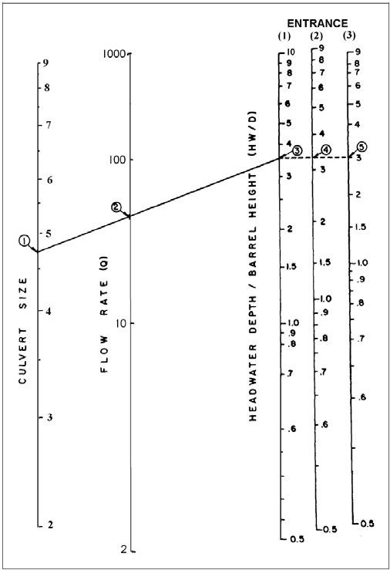

the flow rate (point 2) and mark a point on the first headwater/culvert height (HW/D) scale

(point 3). The first HW/D scale is also a turning line.

3) If another HW/D scale is required, extend a horizontal line from the first HW/D scale to the desired scale and read the results.

4) Enter the value from the appropriate HW/D scale in the HWi/D column (column 2) in the middle of the culvert design chart under Inlet Control. Multiply the HWi/D value by the culvert height to obtain the required headwater (HWi) from the invert of the control section to the energy grade line. This result is placed in the column to the right of column 2.

5) Calculate the required depression (FALL) of the inlet control section below the stream bed as follows.

HWd=ELhd-ELsf

Fall=HWi-HWd

HWd=design headwater depth (m) ELhd=design headwater elevation (m) ELsf=elevation of the culvert entrance (m) HWi=required headwater depth (m).

After the FALL has been determined the design should examine that value based on the following criteria.

If the FALL is negative or zero, set the FALL in column 3 of the culvert design form to zero and proceed to step 6.

If the FALL is positive, the inlet control section invert must be depressed below the streambed at the face by that amount, if this amount is acceptable proceed to step 6.

If the FALL is positive and greater than is judged to be acceptable, select another culvert configuration and begin at step 1.

6) Calculate the inlet control section invert elevation as follows: ELi=ELsf-FALL

**2. Outlet Control**

The outlet control calculations result in the headwater elevation required to convey the design discharge through the selected culvert in outlet control. The critical depth charts and outlet control nomographs are used in the outlet control design process. The following steps should be completed to calculate the outlet control design for the culvert.

1) Determine the tailwater (TW) depth above the outlet invert at the design flow rate. This is obtained from backwater or normal depth calculations. This information is entered in the TW column (column 5) in the middle of the culvert design chart under Outlet Control.

2) Enter the appropriate critical depth chart with the flow rate and culvert size and read the critical depth (dc). The critical depth cannot exceed the diameter of the culvert. This

Control. An example of a critical depth chart is shown below.

Chart 1 – Critical Depth

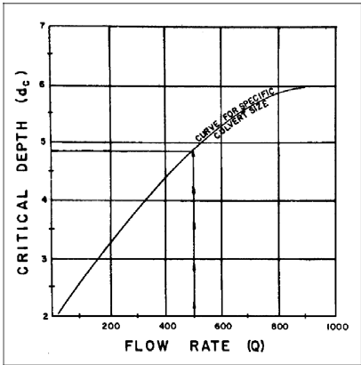

3) Calculate (dc+D)/2, where D is the culvert diameter and enter this information in the appropriate column in the middle of the culvert design chart under Outlet Control.

4) Determine the depth from the culvert outlet invert to the hydraulic grade line (ho) and enter this information in column 6 in the middle of the culvert design chart under Outlet Control.

Ho=TW or (dc+D)/2, whichever is larger.

5) Determine the appropriate entrance loss coefficient, ke, for the culvert inlet configuration. An entrance loss coefficient table is shown below.

Table 2. Entrance Loss Coefficients

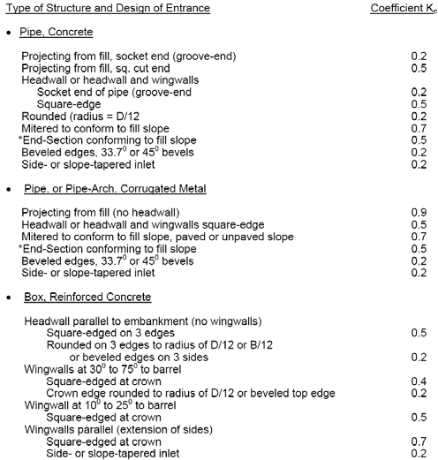

6) Determine the losses through the culvert barrel, H, using the appropriate outlet control nomograph. An example of an outlet control nomograph is shown below.

Nomograph 2. Outlet Control

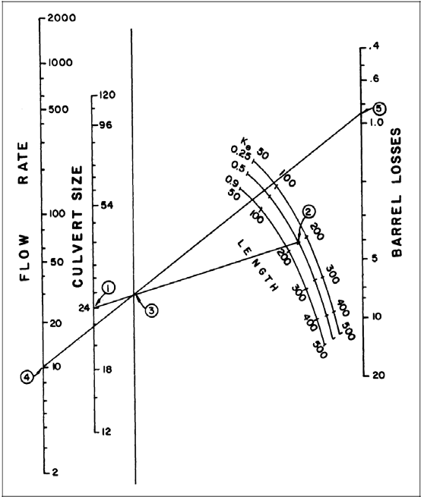

If the Manning’s n value given in the outlet control nomograph is different that the Manning’s n for the culvert, adjust the culvert length using the formula:

L1=L(n1/n)2

L1 is the adjusted culvert length in meters. L is the actual culvert length in meters.

n1 is the desired Manning’s n value.

n is the Manning’s n value from the outlet control chart.

The, use L1 rather than the actual culvert length when using the outlet control nomograph.

a) Using a straightedge, connect the culvert size (point 1) with the culvert length on the appropriate ke scale (point 2). This defines a point on the turning line (point 3).

b) Using a straightedge, extend a line from the discharge (point 4) through the point on the turning line (point 3) to the Head Loss (H) scale (point 5). Head Loss is the energy loss through the culvert, including entrance, friction and outlet losses. Enter the Head Loss in the H column (column 7) in the middle of the culvert design chart under Outlet Control.

7) Calculate the required outlet control headwater elevation.

ELho=ELo+H+ho

Where ELo is the invert elevation at the outlet

8) If the outlet control headwater elevation exceeds the allowable headwater elevation, a new culvert configuration must be selected and the process repeated. Generally, an enlarged barrel will be necessary since inlet improvements are of limited benefit in outlet control.

9. Evaluation of Results

Compare the headwater elevations calculated for inlet and outlet control. The higher of the two is designated the controlling headwater elevation. The culvert can be expected to operate with the higher headwater for at least part of the time. Enter the controlling headwater elevation in the appropriate column in the middle of the culvert design chart. The outlet velocity is calculated as follows.

If the controlling headwater is based on inlet control, determine the normal depth and velocity in the culvert barrel. The velocity at normal depth is assumed to be the outlet velocity.

If the controlling headwater is in outlet control, determine the area of flow at the outlet based on the barrel geometry and the following:

1) Critical depth if the tail water is below critical depth.

2) Tail water depth if the tail water is between critical depth and the top of the barrel.

3) Height of the barrel if the tail water is above the top of the barrel.

Repeat the design process until an acceptable culvert configuration is determined. Once the barrel is selected it must be fitted into the roadway cross section. The culvert barrel must have adequate cover, the length should be close to the approximate length, and the headwalls and wing walls must be dimensioned.

Culvert Design &ample

*Reference: U.S.Deportment of Transportation Federal Hig.'"J way ll.dminisrrorion.*

*'1./ydraulic Design Series Number 5 - H;·draulk Design of Highway CUlverts.*

*r ub/icaticm No FHWA-NHJ-01-020; Revised May 2005.*

Given Data

10-yea r design flow=

Design Head Elevation, Elhd = Road shoulder e!ev=

Cha nnel invert lwation,Eii= Nu mber of barrels

Stream bed slope, So= Approx Cutvert length, la = Fall=

Outlet elev, Elo=

S So-(Fall/la)= H wi =Eihd-Eii= Box Mannings n=

Tallwat«Yalo. hllwat«

m"'3/s

33.528 m

34.595 m

30.48 m

1

0.02 mjm

76.2 m

0 m

28.956 m

0.02 mjm

3.048 m

0.013 concrete

f rom result of the USACE AED Hyd rology Study Appendix A exa mp'e

,)>

CD

::J

Q.

)('

):>

m

0

able now,m"3/s eleYatlol\. m Taitwater va riation determined by

0.5 0.3 using crosssections upstrea m and

0.51downstream of culvert to compute

1.5 0.64 water surface profi e using standard

OJ

I ()

c

0 U'J

1: <.o·

< ;:::!.;:o

......

*\J,)*

S.::eCI O.". 'cnMMil nva'..le=

Trial #1Box wid'h. 8= Trial #1Box heitht, D=

0.035 water surface profi e calculation such as sta ndard step method

m Area of box=

m

<D :::J

CD

;:::!. o<D

1.00 sq m <D.Q

c

. .

CD <0-,

lufo::ll y..,-..-

)<.t Y•U '=' 30 u wiuwe ll

Ill

:::J <D

Techn ical Notes per Desi gn Chan Expl anatio n========>

*See* CULVERT DESIG N FORM

IE' 3

(2.b) Hwi 0.800 m

(3) fal 0

(4) lni=thi+Eii 31.28 m

(S.a) -w 0.51m

mult iply result from (2) • D· obtai n 0.8

fall · the depression of the inlet below the stream bed -is *zero* for culverts on grade elevation of headwat er i n i nlet control

taitwater depth as detrmi ned for design ftow from tailwater variation table

X

I»

3

"5!.

CD

(5.b) c>: 0.45 Chan 14A crit ical depth f ot recta ngula r crosssection from cha.n 14 A · read 0.45 for 0/8=1

|  |  |  |  |  |  |
| --- | --- | --- | --- | --- | --- |
| (1) | Q /oJrei=O}(N"SJ= | 1.00 m"'3/s-m | divide design Qby number ba rrels+width) | ::J | <D |
| (2.a) | Hwi/O | 0.800 Chan SA | Use result from (1) to read across cha.n 8A to second li ne (90 o wingwall) - r ead 0.8 | m | ;;!.  U'J |

(5.c:) l':+e)ll 0.725 m (6.a) v::er T'J/ or (e>:+O)h,Ho 0.725 m (6.b] tc.: 0.5

(7) ,. 0.16 m

(8) lrto:Eic.+H+Ht 29.84 m

oontrol headwat«

eleY 31.28 m

fiA oo.rtle.

(0.4S•1l/2=o.ns

select g reater val ue between (S.a}and (5.c)

loss coeff icient for outlet

H =(1+ko+(19.63*n"2)/R111.33)•vA2/(2•9.81)) (sum of i nlet loss, f riction loss, a nd velocity head)

sum of H + Head.,n +exit elev. R AJP: 0.25

greater val ue of (8) or (4) lrllet controb culvert flow C4pacity

welod1v O\lde1nltkal de h welod1v

..otmal de h

._;,e·TW ..:

1.00 mjs

2.22 mjs

Out let V if fu l flow occu red *He,*ex\t..<eloci':'f hed= O.S7 *m*

I nlet V if pa rtial flow occured flo-.... c!epth: <5 ft

welod1y 1.31 m/s _.•-. -...- -.---..--.

fromn orm lde.;:oth u k

0.7;2 ,.,..

tOO

:

**..ooo**

c-·-··-----. I

I**CHART 14 A I**

I

50 ( 1) ( 2) (3 ) I. /

**2500**

**1$00** ........, ,.**eoo """"" Box**

""

e **Q:2.12 m3t.**

; 20 **01&•'1,41 m31:1.'m**

0.

• *7* • I. /

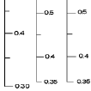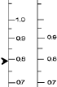

• y /

• • ./

• f • g 0 '



*.$* **1n1oc** ""

,.,

.c. 10 '·"' ,

• (2) **1.90** ....

(>) **2.05** • ••

0.0 /

!

:a 0.$ / /

o.s

••

**1500**

r**6**·

"'

c

..............

..•

... ...

3 / **de CANNOT EXCEED TOP OF APE** 0

3 ................

/

0.1 , ,I I I I ()

E -.& QA. O 2 *Y1J!'7* :.

-··*

E

... - ---- 10

/ /

.,..-

3 5 •

QIB

1.0 .. /

<.o·

<D :::J

;:::!.;:o

o<D

<D.Q

c

U)

000 .......

"

/ M

:r

0 ·.. /

.; 70........./ "' ... - ;;;

' 0.0 SCALE WINGvvALL rr-."tf>-

**F t.ARE CP**

0

600

500

3.

3

2 ,6

2

**•e *ol* section (m) O•flow (m•f,)**

/

**de .0.487((0/B)i)V)**

/

*v*

:::J 3

<D

;::!.

U)

400



..•*.L* **<lc CAXNOT EXCEED TOP OF ptPE**

' " I ?< I ..

.,.,.... ··• .·, '.**l**.**'**...**l**.**:l**..**-... A••• •** . **,QQ**

HEADWATER DEPTH FOR BOX CULVERTS

WI TH INLET CONTROL

tO ••

**A.dpted fromB ;au of Public: ROOICI•**

30

**Critical Depth-Rectangular Section**

Culvert Desgn

Culvert Design Form

..

-

" i ..

I

J

.. -

•w.. 0

•

' ' 0 u

u

!

c

0e: -

rl'"

f-J

**UU01l.li**

d

!l.

Q

2 .. I

z

"""• :

"' •

I ."."..'."..'.".

• ..

"0'

0 a I • -

I! .. r -•

.. cc• *li* ,_

**c**

,-

- -*t*

• M • -• -•

'' - •

•

w " •w

•"'

- •

•• . •

*t* .

• ;;

• • •

" a c

-w I• •

:> • ;:;

I

•

I

..- ••

§ • **t;**

• I a-. *,r*

0 -.

H •.

c 11 i• • .

iI·

.j

*,r J*

2 • -

• *-=.. j*

•• **1**

••

r-- r / ....,_ I iE i

0 •.

L

.. .. I

:-· ; :

.. : . '-

0

a

c..

w• ;; .- ,.

• •s

• • ! *jt* s

!-•

•

ti 's;

*:*b*··*

I - hl -

I

5 •

*i* •••

• - u

•- • "'

H w• • - •3

I' •-

' -

." •

.. N - *J* i· !

•! .

• • •

• •.

• - .

D 0 •

u• • •

• I ie il .. *t* .

I "• •

; n**5** f • !:iU i

• • I I ' -

·--

u

0 • - •

• e e

.. 0• • • •

'

"

*t* • ' **Q**..

............

.**c**. 0000 -

• • •

, - t •

**,.•••!1** ...

• *r* **;oc**

**i** • **..**

• • • •

0

0 e !

• • *:*

**iia•:;u:;J**

**:*.*:*t*,*.*3*t*.. ."i:**

.

• •

**"I.U11,.tc'fnt** u•

•

i ;;

•·.•-.·..·...--.·.-

dc=[ (Q/D)^2/ g]^1/3 (dc+D)/2

ﯼړﮐﻮﻠﻤﻌﻣ ﻖﻤﻋ ﻮﺑوا د -١ ﯼړﮐ مﻮﻠﻌﻣ ﻖﻤﻋ ﻢﻴﺧو -٢

-٣

ho= TW= (dc+D)/2 -۴

ﻪﺨڅ لوﺪﺟ ﻪﻟ (ke) ﺐﻳﺮﺿ لﻮﺧد د ﯼړﮐ بﺎﺨﺘﻧا – ۵ ﯼړﮐ مﻮﻠﻌﻣ تﺎﻌﻳﺎﺿ ﮏﭽﻠﭘ د -۶

H= [1+Ke+(1963*n^2)/R^1/3]*(V^2/2g) V= Q/A R= A/P P=wetted parameter

ﯼړﮐ ﻪﻣﻮﻠﻌﻣ ع ﺎﻔﺗرا ړو تروﺮﺿ د جوﺮﺧد ﻮﺑوا د -٧

ELo= Eli- (So*L)

ﯼړﮐ ﻪﻣﻮﻠﻌﻣ عﺎﻔﺗرا ﻪګﺟ ﻦﻳاﺰﻳډد ﻮﺑوا د -٨

ELhi= HWi+ELi

HWi= D[HW/D]

HW/D= C[Q/AD^0.5]^-2 +Y+Z

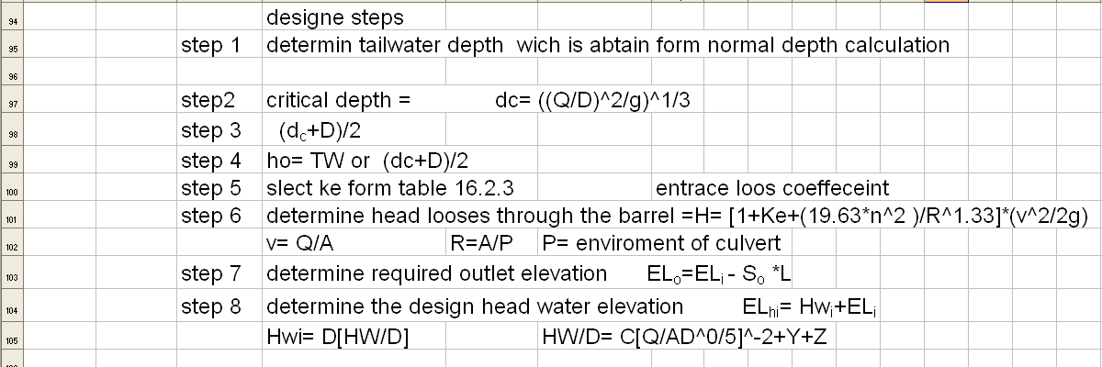

14 l l



given data

,>.>I j;>J *j!-* J *,:.* ,_J J[10-year design folw =

l l l

-

3.23928 ems from abave caculation

t) w' J ....s >"' J road sulder elevation

.. Design Head Elevation, EL

Channelinvert levation_!Eli=

.. (_4) J Jl Number of barrels

34.595 m

33.528 m

30.48 m

1

form survey from survey from survey_ from survey

w J J Stream bed slope, So=

0.458 m/m from survey

J JJ1*fo* Approx Culvert length, La=

, , , J Faii=Hwi- HWd

Outlet elev, Eol=

----+-

S=So-(faii/L =

Hwi=Eihd-Eii=

Box Man-ning,s n=

I 1

76.2 m

Om

-4.4196 m

0.458

3.048 m

0.013

I

from survey

r

Trial #1 Box width,B= Trial #1 Box height,D= Area of box=

R=A/P

Inlet type= squre

.. 1m

1m

1 sqm

0.25

P=(?*+(?*0 A=B*D

/Y I **... 11101.....1** IW . .... **c··** ........, ......... **0**

t + 1- .. ..

, !1

1 Q/barrei=O/(N*B)=

- 3.26928 cm/sm

- N= nose of barrel B= wide of barrel

!$ 2.a Hwi/0 3.048 from chart AS acurdance to 0/B(sqm/sca)

r- +

, !! 2.b Hwi 3.048 m I I

I I

1- ..

- 1--

$00 3 Fall 0

r-

$0$ 4 Elhi=Hwi+Eii 33.528 m

r-

$0! S.a TW 0.51 m

r-

$0) S.b de 1 m

r-

- inlet control head water elevation

-

- chart 14A acurdance to 0/B(sqm/sca

$0 S.c

l(detD)/2 1Im

I I I I I

, $05 6.a greater TW or (dc+D)nHo=He

- -- 1 m *Reference:U.S. Department ofTrans portation Federal Highway Administration.*

$0, 6.b ko= 0.5

r-

- haydrol1c

101 7 H= 28.87 m by this (H=[1+Ke+(ku1nAnfRA133)]'(VA2f2g) farmula

, -

8 outlet control

r10-$ elvation Elho=Eoi +H+He 25.45 m inletecontrol

headwater

101 elevation 33.528

.. ... + 1- .. - 1--

fullbox outlet I I I I

110 velocity 0/(B*D) 3.26928 m/s

..

r-

inlet control

, 111 outlet velocity width*TW depth= 0.51 m/s

"'-

T T I I

2000

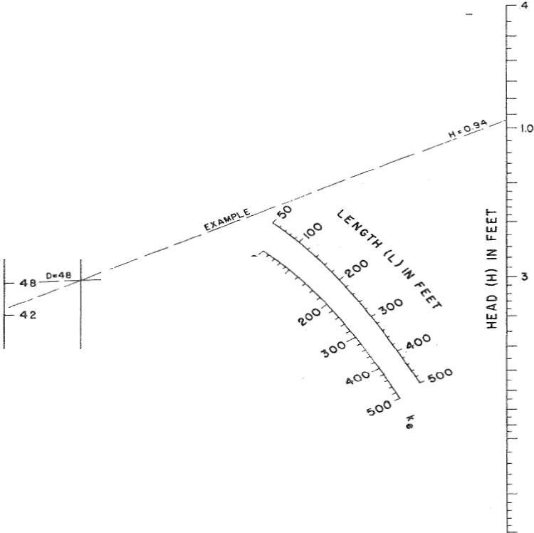

J-··-- z s

...

:: ..,

:L..., -

Sl:opt• So:- ,

1000

z z

':,:"_>' ::.

SUBMERGED OUTLET CULVER T flOWI N G FULL .5

.6

C/)

800 11 20

600 108

500 96

AOO 84

300 7 2

66

2.00 60

for outlet cro wn not &.ubmtrQed, compute HW by

methods deae r;Md in IM ct•ai9n proced ure

.a

2

...... 54

.

0

:X:

'=o'

"

z CJ)

- - - - -

L •UO

- 00

*a* 100

w

<..>

z

-.70:5

*u.l* "'lo _...- -

z

Q.. ,...

(!)

a:: o....:::----

0

<{

::t: 36

<..> 60

*tn* a: 3 3

w

0 50 r



w 30

40 <{

0 27

30 24

4

5

6

.. a

•

• 0

*0·.s-* - 10

21

20

18 20

10 15

8

6 I 2

5

4

BUREAU Of PUBLIC RO AOS JAN. 1963

HEAD FOR

C ONCRETE PIPE CULVERTS

FLOWING FULL

n=0.012



Table 4-2 Inlet Coeffi<ients



Pme. *Concrete*

Projec6g from 6D, soche! nd(gro;.-e--eud) Projec6 g from £iD, square cu: end F.:.:eadwa:!l or headw·.Ji.md \\

Socke end ofp:Pe (groove-ald.)

Squa..ge

Rouad.d [r..fus = JJ12(D)]

Mitered to cotm ro £IIslcpe

-End-Sectionconfor,.,..;,g to £ill slope

Bevefed edges, 33 7" or 45<> *be=:ek*

Site- or slope-:;;;pered t

Coeffir.ienr K.

0.2

0.5

0.2

0.5

0.2

0.7

0.5

0.2

0.2

Pme. or P!:?e-C. onug:rted Meta3.

|  |  |  |
| --- | --- | --- |
| Projec6 g from fill(DO h=O'.dn.-all)  F.:.:e aD or headw·.Ji.md \\ ralh sqtm-e-edge | 0.5 | 0.9 |
| Mitered to fillslope, *pr.:ed* or u:n.p.r.;ed slope |  | 0.7 |
| -End-Sectionconfom::Olg to fillslope |  | 0.5 |
| &t"efed edges, 33 7" or 45<> be;.e·ls |  | 0.2 |
| Site- or slope-z;;;pered t |  | 0.2 |

Box. R.Urorc-ed Concre:e

F...e:tdW3!1 p.:u.to *e:bml.m...m*{uo 't\6lvdb)

Squa.. ged on 3 edges

Roundon 3 edge_ s ro taefus of [1112(0)] or be;."eled edon 3 sides

Wtnp.Y-ai.s at 30" to 7*i-* to bare!

Squa..ged at c.nm11

0.5

0.2

0.4

Cro"-D edge_

rowd.ed to rad;.s of [lll2(D)] or bettop edge

0.2

wm.n..-a .s a: 10" or 25"' *to* ban-e}

Sq ged at c.nm11

WEnp.Y-ai.s para.iJ=! (e. ion of sides)

Squa.ged at c.nm11

Site- or slope-z;;;pered t

0.5

0.7

0.2

• Note: Eud Sec-tioru. con:bm:ring to £U slope, made of erthe"" metal or CO!lCtm, «re the sec-riom comm::mly on-ailabfrom manufacrurers. From !iruii:ed hydr..wi: tests they «re equi.--;aJmt opaa:fon to a be-adwan in both

!!::l=! md outlet c-outrot Some end sec-ions inc.OipOla.rin; a dosed pa m *tbefr* desip *h.n:e* a superior bydrat.ilic

perfon .mce.

SottrCe: f'J>S:5

20

- **-·v-** --- -·--··

**4.5.14** l\lalllling's n Values

For only ptpe JS allowed except for dm '3V culv-erts. For culvertequal to or grealfr than inches in diameter. co ted metll p!pe IS allowed if it IS b!lU!IJioons \nth a concrete-poured mverl. Table 4-3 recolllll.lellded n,t!hle!;_

Tab !> 4-3 Manning's IIralues

Wall& Joint Descmtion



Concll':te Pipe 0.011..() 013

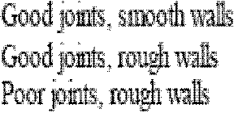

0.014-0.016

0.016..() 017

Concrete Box Good JOmls. smooth fmished

P""'""'mt< rough, llllfinished w31ls

0.014-0.018

Com1gated



::Vfetll Pipes and

Boxes, ,'i.!mular

Helical Corrugations.

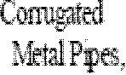

Full Circular Flow



2 1!2-lllCb com

*6* 1-lllCh co ;aoons

5 by l-inch comJgallOtl!i

3 by l-inch co ;allOns

*6* 2-inch strnc llfalplate

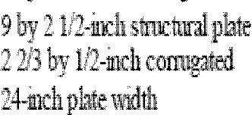

34

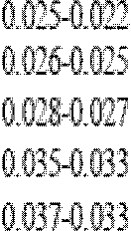

0.0' 4-0. 012

:1\Jte: For furtlllr infcinmtlon coocern11g l\l:lilllllllg



ofH!gmvay Ctd>-erts. AdmenslrallOll

**21**

**Appendix C- Culvert Debris Protection Devices**

**Site Adapt STRAFLIN**

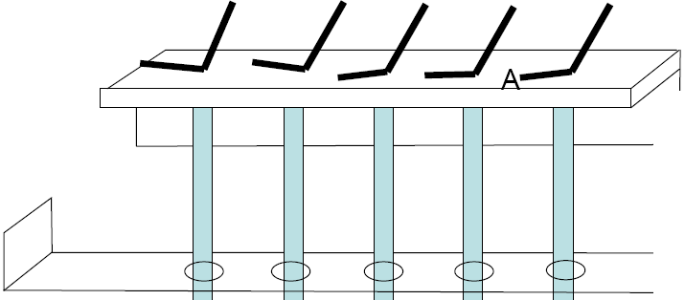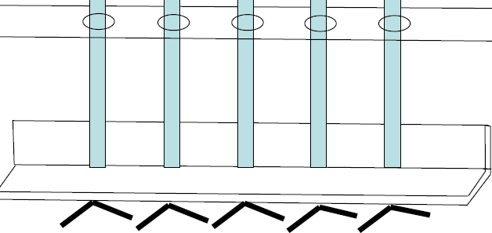

A

**StraFiin** Culvert Debris Protection Plan

A Cast-in-Place

A

/._:.

A

TYP

75mm

I

TYP

HI eIm20



NTS

StraFiin Culvert Debris Protection

Plan

Cast-in-Place

Billl of Material

A. 75mm X 75mm X 9mm ASTM A36

Grade B, Angle, Hot Dip Galvanized, Cut to Length (2 Pieces)

B. 50 mm X 9mm ASTM A36 Grade B, Flat Bar, Hot Dip Galvanized, Cut to Length (2 Pieces)

C. 20 mm ASTM A36 Grade B, Cold Rolled Round Bar, Hot Dip Galvanized, Cut to Length, 5 Pieces

D. Reinforcing Bar, Number 10, ASTM A615/A615M-05a , Cut to Length, (10

Pieces)

Designed by: William Stratton CPT Darrell Flinn Mehtarlam PRT

4$

ST£ELPPI(SOm,.,f!tA Sm..,WAU.)

'IF-tOED TOf RIC)(IIT $ X.aE.MI.)

(/)

c.

;:

!

,,, I ....-

$TEElfiWIE ('

STEH Pu\11:(lS•IWII T'f'P.

I ""'-

. tw'I'U:(II"""\1

SALERNO BOX:

B£COMMfiNQATI ONS·

• MOOI.A.AASYSTEM(OU£ TO NCONS STENCY OF CIJL\'ERT $1ZES)

• lOCN.NAtlow.lCQNTIV.C:T (10 JtiCCI'<'>I,Qoii'LQYW('IIIT*01'* Uolf.l

• EASt.V'IIIJilT tM'CEAS'IA....O ....STN.I.E!)

FEATURES.

• V1LIZE$8N'Ft.elOIEXPNIOEOMETM.

·IYA.Tf l'tf\.Cl\V

• PAE'IS'IT AOC€39

• LAStV l fV,MSP()It'f£0{1. I«$1A1,.1,.{0

*c*

r­ m z::::0

0

DJ

)>

, PLAN VIEW

&101 &CAL• UO

I .... I

"' I "' I

<OLD""'""'"'">

I n""' I

• AVAf - T£ftiM..9

m

0

()

c:IJI

<"<0"

(II ::::I

' ., • (IQO f"fTTX I<IOO IMili OOfm'lj I >

N

1

A (, · ··J

21 I

. ..k .L

:::::1-::::0

<D.c

. .. . .

!TEe. 9AIFLNCi13-;.

STEELS/oR

($Gm"')C $f"m)

!lii I,J'

I

|  |  |  |  |  |  |  |  |
| --- | --- | --- | --- | --- | --- | --- | --- |
|  |  |  |  |  |  |  |  |
|  |  |  |  |  |  |  |  |
|  |  |  |  |  |  |  |  |
|  |  |  |  |  |  |  |  |
|  |  |  |  |  |  |  |  |
|  |  |  |  |  |  |  |  |
|  |  |  |  |  |  |  |  |
|  |  |  |  |  |  |  |  |

Oro

(!!!. =,-

::I

!. !

t4x'

x · Kj

(II

::I

!ii

I

--'---

""""-

, FRONT ELEVATION

1111 SCI\Lii • l !0

M6Jffll ! PftP"FFf t!S•

COMCRETE: 'l$W'•l1'1) "eoooc.d)

$T'[I:L Rlll*'QRCt l.rLNl Mil{ 4l0mo. !I')'•110"")

, SIDE ELEVATION

\i•'t SC Io • UO

• REAR ELEVATION

l U I SCitol£• 1 '11

l

hi !

n

• I

I , t.'AI<E AU.. OftATI <lP(N!'<O!I ! oer...otOOno-, THI!I NOui.OWfl\V

TO Tl-IE CRATI"Q I'FRONT THAT OOSNECTS THE TWO""-L£0

P.O.,ELS.A.'OTO THE IEAAOAATE.

2, "'1\!GtroH:EUAAAI'ROWT ISiO 9lQC( I.NIGl 0£1.1RIS AAO

ltll!IT(NQ.I'I' ACCCSS TOTi lE NSI OCOttATt,

$, AU EcnONSFUET....aDEOUN.ESSOUTEAWISE""OTEO.

Sl!'IUCTUlW.!ITEn. A3$,M0M l'•f'Y 98

STEELF1: MO OOAASTA.ONG.G....,.,\\J\LL

...1. 1-lli"!C; A'H!i(H,

,.-.ceoua ,.*1101*

*AI <:!;,.. .;q.,.l'n j,* .. *A_,lh'l'n*

GRAPHIC SCALE

.'!OTE.AU.OIW S.O! NS A....ciOR O ::NS$&HO'"".tl NCALI..OVT&t>iOTES E 1-. lo!ILL \.!ETEFI.l H.ES$1N:liC...TEOOTHER'.f.I$ENOfEO.

**Appendix D – Causeway Debris Protection Devices**

**Site Adapt Roadway Causeway with Grizzly Cage**

25

A 0 Q H

UPSTREAM

J.'!I:!CNtD

DOWNSTREAM

I-J-

@ TYPICAL ROAD CAUSEWAY

·•· SECTION A-A

seN.Nl'l

- - WNIJ\.M t!i(o

$tOI'E 'l"""'-

r-1 *J* IIQTMWJIV$"t'<$W\

I

<

[

tf J-{ [1 [l rr -1.1:.R" ['1 tf 0: 1-<.J-{

\,"LL.CI'I)'>i$AA(i i'<Nil. U$0fi<ER'Io $T"'TEC,

J,AU. *II.A$0NIR'f* W()l;)( IIIICU.l>liEI'Ci!.TEO.

C,llliU"III()Ioi,OOitiNCLO IIVJiet.IAN....o. \U.MUCUII v.A..L10a.

oct"""IXI II'I' m:; lolGI'GR.

S.$lM(loiiROI!io)'ll!tA.IOWW 1\".t SI"EEw£9HUSPECEfi EOFOR

ftf....O&teloi!!NT *tJ'* CCII<fCIIlrn!Sl.o\liS NII!SH TO1!111! l'll!l>'fl:lCifThl!l\Sl11!

IWD.IU'DU;;;$H $NOJAVA._- .,

*I.*OOt.Qifi'E r.otll $H.N..t.$€ l'fi.Of'OII.'I'Is£0*IJ'f* VO.uw£'1'1ltl-1J' \'V'THtl ca.ot,.,Y

>II

)>

m

0

l1l ()

..;! ,.._,

N tl -{ [!_ tl 1 '""

0\ R' R' *\*' F(* R' . '

& f ' I CAL ROAD CAUSEWAY SECTI ON 6-B

.../00 \ :2

"' . ••••n• "'""-

"''"·Of'' "" \ /

"

I

JV.tl00f'M11J totOIIC lt(lC t·ftt nt ...llt.CC*!II:D!2-IIYl'VAU.C CHU.II.Jt

mM !oeW!oUtWL DG IIGJCt:ffO nVIlll'll cor.jsrcll

*1.AU.*OOsCI'kiETO rtA\'EJ\&wX-<t T\Iw&c <ICWYJr.T AU fooe& EXI'A.'C$1\».

JCt!O"SSHOUlO I!I!DAtltCI !lAAV enw"..CNI!Al:HSI..All.

SOT£:

1.f'lto.'W 01-\.).1 3WMIS.,s

lllll.fS TOStC'-*OC.tlUA ClldJ.,!.

t:"'lCIII!I:-l

UNOTI.U$y._ wEl'El't i.Os080n OH

STCII:I'TO ioWU!CI<lut.YC"''X

lW.>;()JIOP...,. I<IN &Ot.T.&E<)JIIE PCI"<l$

jli

j " ;

-1.,

5. .

< e

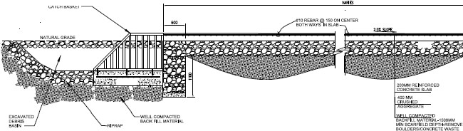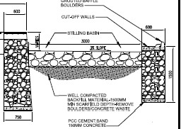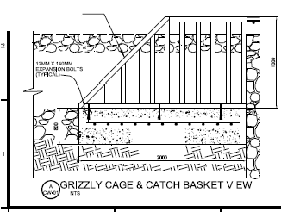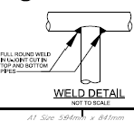

(I)::J

::L;;u

0(1)

<D.c

Ills::

iii'

10.

-9CII•I<Stwloi_X It0:1\t'd STEEtPPE.,.HllEO fO!l<.lf<IUl'.f aHu.E&

.littlWIOOU"I

...

\. *I*

WN. CF'it'.IW

Of'U4M:lIIEI"' Uii'

!I TI!I!L I'j:'e.

RIP..RAP SCHEDULE

I·i

I

i,,

*Ill*

- '\.

|  |  |  |
| --- | --- | --- |
| =col | iii.ti'S"-i1oiieiU11 | |
| I | KG -  <00 I | (;loT!il11'  O.W |
|  |  |  |
|  |  |  |
|  |  |  |

til

@ LY CAGE & CATCH BASKET PLAN VI EW

OO.a:v.t. OTEfl

1, Tl!IS1$ A $1fflMJAPT OUI:lH,CtW!l!iSro:t AAO.IECl$'!;A'TI,A;& $110'AW 0'<1 OilS$11E_

IJlN>TPI.»i"-'08€¢110'<18AIENI'et<oSOTO&I!O'A''IEV1. 1£ EAAO IONAt. Ch<f!<illl:lt>S,n.f COHlRACTOft tKlU.AO.VST floE EXIEWT Of lllf I'AOJECT f fArt.ft!S....11'11 0.f

COAOA·I Ill NJ"'ll\', ll1C l.aU.ISTWDIT!II,.U lltw:;l O N PAAHIWA!II K l'<illrlNCir

WN)I YMPIT>IEW"41t J<V"'EJICEMQ.IeClQC+.l$liiUCfi¢W n iiEO\II'l:UI,

'·O.E .-LI!:!<iW£ '<11*01* fi1E WAY W.Y liEA(U.l!ll€010rou.o....ASNl..C-1At P0e l3l.£ Tri£ r.xiS'II'<toWN:t C,IIO'AT\'1!11 1'1«- r.lf i!NIN"ffi:J W.Y JIC'Ct,IIU:-AOni I OOMilRIIClt:l!i I'U.l'tCli..QNG MOllE ()ONSlii:UI:tlllN AAO £lCPA'ISs JCI'ITS.. NXJrtcfW.1\.0WOOPitltOl r0.1\.fE8$UCH SlON£1\.0WOCFlECTOI'IS.A.VIJFENCe AIJON',EHT8*NO* Nl¢1!0'1:1'4tlETAil8

L 1+1.11Vll )11;011 I!IWON lt11: :S!AAOAIQ)IlW..,.,N!:.

T>lll CNJ&£1A'o'-V PA'/EW'T ISISTb..;)tl> (lilt Udi!T IIHCI.E.!l',o&;IJNG£'1.&Vo'. oll1'-ICKUP*m!JC'(J*

1! *b*

lo. I

>

21

!i iO t1

"'

1

I

1

T'VtR'I Ot.OI1> *0* AAO to.'I' NOT eE$1.11TAU FQI'I;1-EAW TRIJCi( OA.TRN::J<EO VEiii:::UU\R TAAR't:

Wll'l!OiJTSl'RvC:'l\IIW. uoctfl t.-.Tb!<:S.

$1 1.

..

""""""

CKA. ».T bWtOI\

$TON$1111.1Cfl.l1Ui

lli\fl

i,f.

a.

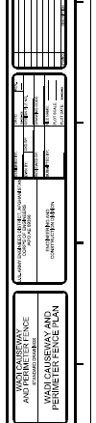

!:"'E,I"oiW"'

WI:G>fl'

IICRC '<f i.N..;rll

'nW<GIIE WSilE

... "' 1110

i

!!!.

i

"'I

!!I n CD

e:

()

Icll

*In*

'<

'

'

'

G)

'

' :::::!.

'

N

N

-< () Ill

=

CD

)>

m

0

()

5. .

eii=

::L::J

0

CD..c

c"e"·:::;·

::JCD

3

CD

3.

Ill

'' ......... _

---

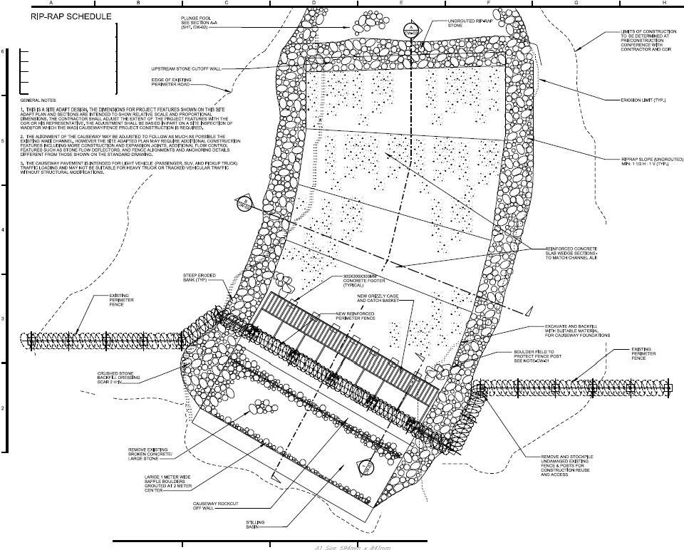

@ AUSEWAY AND PERI METER FEN CE P AN 1 1

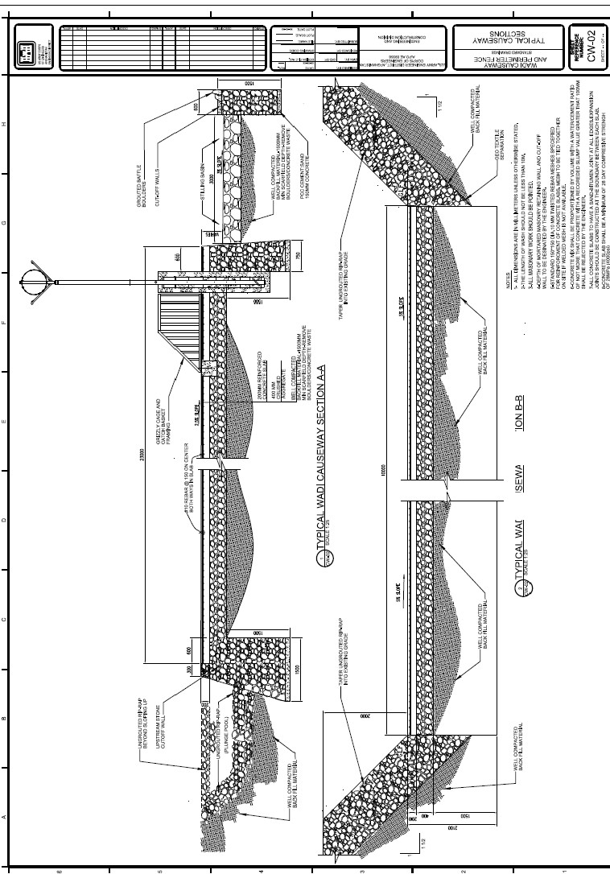

z

0

;:::

()

UJ

(/)

'

3:

UJ

(/)

«::>

()

i5

«

3:

-<{',

()

0:

,

.f

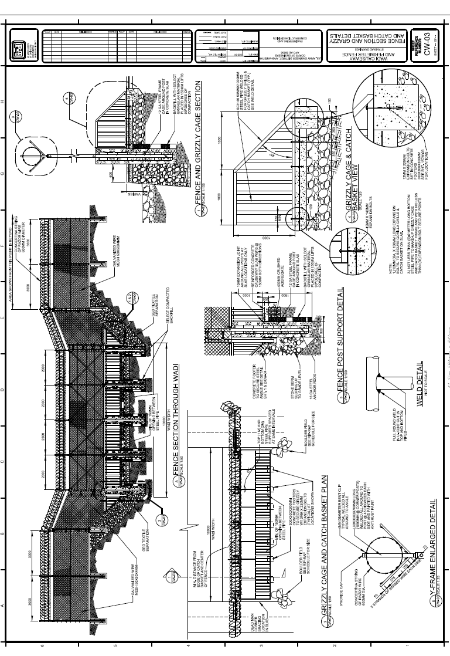

IllI I I "".H_i.o,i.O..<..j.c...-.........., NOil'tl/\313 ONV N'dld I

311IUO A i U0:)3SIOVM

- ·-·. ..._, i:. UI/O't\

V Wl--1

lON3J tlli311tl3d 01/V

A\'1,\Jsn'I/:JIC'YM

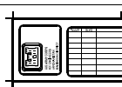

X



